21 DAYS PROGRAMMING CHALLENGE

Day 2

Creating Objects in Different Ways

There are two ways to store object in a memory. The first ways in which the object is stored in stacks whereas in other the object is stored in heaps.

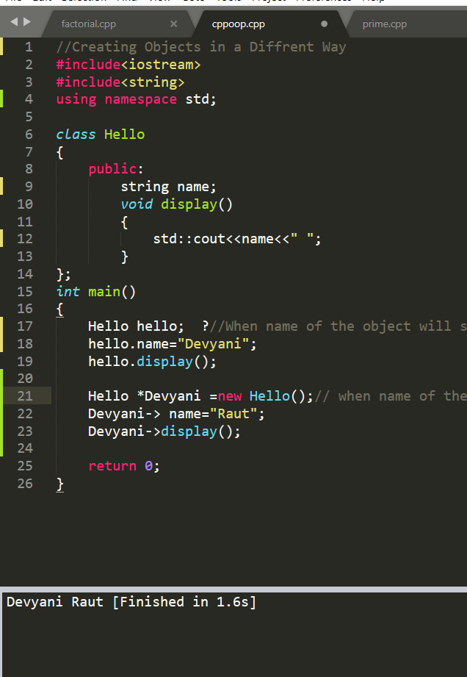

Scope Resolution Operator

In scope resolution we derived the method of the class outside the class.

